**API BASED SPACE WEB** ***‘GalaxyPoint’***

**A Major Project Report**

*To be submitted in partial fulfilment of the requirements for the degree of*

**Bachelor of Computer Application in**

**(Computer Application)**

*By*

**Mehrunisha SC21CS301050**

**Mohd. Aman Gouri SC21CS301052**

*Supervisor*

**Mr. Indra Vaidya**



**Department of Computer Science**

**Faculty of Science**

**MEDI-CAPS UNIVERSITY, INDORE**

MAY, 2024

**DECLARATION**

I hereby declare that the project work entitled **“GalaxyPoint”** is my own work conducted under the supervision of **Mr. Indra Vaidya** at Department of Computer Science.

Approved by HOD Department of Computer Science, Project Coordinator, and Faculty of Project. I have put in more than 75% of attendance with supervisor at the University Department of Computer Science.

Further declare that to the best of our knowledge, this project report does not contain any part of any work which has been submitted for the award of any degree either in this University or in any other University without proper citation.

Signature…………………………

Place: Indore  Name: **Mehrunisha**

Date: May 2024

Signature…………………………

Name: **Mohd. Aman Gouri**

**CERTIFICATE**

This is to certify that the work **e**ntitled **“GalaxyPoint”** is a piece of Project work done by **Miss Mehrunisha** and **Mr. Mohd. Aman Gouri** Under our Guidance and Supervision for the degree of BCA from Medi-Caps University Indore (M.P.). I certify that the candidates have put in an attendance of more than 75% with me.

……………………………………………….. ....…………………………………………..

Signature of the **Supervisors** Signature of the **External**

**Mr. Indra Vaidya**

…..…………………………………………..

…………………………………………… Signature of the **HOD**

**Ms. Monika Chourey Dr. Jitendra Choudhary**

……………………………………………

**Ms. Priyanka Jain**

Signature of the **Project Coordinators**

Place: Indore

Date: May 2024

**ACKNOWLEDGEMENT**

We extend our sincere gratitude to all those who have been instrumental in the successful completion of our project on the “GalaxyPoint”. Their support and guidance have played a crucial role in shaping this endeavour.

We are immensely thankful to the faculty and staff at Medi-Caps University, Indore, for providing us with a conducive learning environment. Special thanks to:

**Dr. D.K. Patnaik, Vice Chancellor**, for his continuous encouragement.

**Dr. Jitendra Choudhary, HOD**, for his valuable insights and support.

**Ms. Priyanka Jain, Class Coordinator**, for her assistance and coordination.

**Mr. Indra Vaidya, our Project Supervisor**, for guiding us with expertise.

**Ms. Monika Chourey and Ms. Priyanka Jain, our Project Coordinator**, for their valuable suggestions and feedback.

Their unwavering support has been instrumental in the successful completion of our project, and we are grateful for the knowledge and we are grateful for the knowledge and experience gained under their guidance.

**ABSTRACT**

This web development project(‘GalaxyPoint’) revolves around the creation of an engaging platform dedicated to showcasing the wonders of the cosmos through NASA's Astronomy Picture of the Day (APOD) API and NASA Image Library API. Users can navigate through a visually stunning collection of astronomical images by selecting specific dates from an intuitive calendar interface.

The website boasts a seamless user experience, featuring a thoughtfully designed User Interface (UI) that enhances user interaction. The interface ensures easy navigation, allowing users to explore the cosmos effortlessly. The project leverages NASA's APOD API to dynamically fetch, offering users a daily cosmic exploration and display the celestial image corresponding to the chosen date.

To personalize the experience, the platform incorporates robust user authentication functionalities. Users can register through a user-friendly sign-up page, providing them access to exclusive features. The login page ensures secure access for registered users, maintaining the integrity of individual accounts. A logout page is also implemented, offering a streamlined exit process.

The design philosophy prioritizes simplicity and functionality, steering clear of unnecessary complexities. The absence of social sharing features streamlines the user experience, creating a focused platform for individual exploration of astronomical wonders.

In conclusion, this web development combines the awe-inspiring imagery provided by NASA's APOD API with a user-centric design, creating an immersive and educational experience for astronomy enthusiasts. The incorporation of login, sign-up, and logout functionalities ensures a personalized and secure interaction with the platform, making it a go-to destination for those seeking a daily dose of celestial wonder.

## Table Of Contents

|  |  |  |
| --- | --- | --- |
| S.No. | Title | Page no. |
|  | Problem Statement | 6 |
|  | Why is the particular topic chosen | 7 |
|  | Objective and scope | 8-9 |
|  | Process description including ER, UML | 10-11 |
|  | Hardware and software | 12 |
|  | Functional and non- functional | 13 |
|  | User interface (Front-end) | 14-25 |
|  | Backend (Database) | 26-27 |
|  | Testing technologies and security mechanism | 28 |
|  | Contribution | 29 |
|  | Limitations | 30 |
|  | References | 30 |

**Problem Statement**

Our website offers a diverse range of valuable content, including news, the Astronomy Picture of the Day (APOD), and a gallery of astronomical images. While our platform provides rich and informative resources, there are several challenges that need to be addressed to enhance user experience and usability.

**Content Visualization:** While we provide a gallery of images from the galaxy, ensuring the presentation of images, graphs, an multimedia elements in an engaging and user-friendly manner is crucial for holding the audience's attention and conveying complex information effectively.

**Content Accessibility:** Users often struggle to locate specific information, such as details of astronomical events and updates available on NASA's website. The lack of a streamlined and efficient search mechanism inhibits users from quickly accessing the latest and most relevant data.

**User Interface (UI):** Our website's user interface is designed for optimal user experience. It features an intuitive navigation menu, responsive design for various devices, and an eye-catching visual layout with legible fonts and high-quality images. Clear call-to-action buttons guide users to essential actions, and forms are user-friendly. Accessibility measures include alt text for images and keyboard navigation. Fast loading times and efficient search functionality enhance user satisfaction. Continuous user testing and feedback collection ensure ongoing improvement. The design is consistent and mobile-friendly, offering a cohesive and engaging browsing experience.

In response to these challenges, we aim to develop and implement solutions that enhance the accessibility of content, improve the user interface, and optimize the visual presentation of data. By addressing these issues, we intend to create a more user-centric website that delivers an exceptional experience to those seeking information and inspiration in the field of astronomy and space exploration.

**Why is the particular topic chosen**

**1.** **Astronomical Dreams and Passion:** The decision may stem from a personal or collective passion for astronomy, stargazing, and space exploration. The desire to share this passion with others and create a platform for like-minded individuals could be a driving factor.

**2. Educational and Informational Value:** Astronomy is a subject that fascinates many people. It provides an opportunity to educate and inform the public about the mysteries of the universe, celestial events, and the latest developments in the field.

**3. Inspiration from A.P.J. Abdul Kalam:** A.P.J. Abdul Kalam was a renowned scientist and former President of India, known for his contributions to space research. The decision to include news related to him may be to honour his legacy and inspire others to pursue careers in science and technology.

**4. Curiosity and Wonder:** The cosmos has a universal appeal, evoking curiosity and wonder. It can inspire individuals to explore and learn more about the universe and its infinite possibilities.

**5. Community Building:** Building a website around these topics can help create a community of enthusiasts with common interests. It provides a platform for interaction, discussion, and knowledge exchange.

**6. Educational Outreach:** The website may serve as a valuable educational resource for students, teachers, and anyone interested in astronomy and space science.

**7. Promotion of Scientific Literacy:** Astronomy is a gateway to promoting scientific literacy and critical thinking. The website may aim to engage and inform the public about the importance of science and space exploration.

Ultimately, the decision to create a website on these topics reflects a passion for the subject matter and a desire to share that passion with others, educate them, and foster a sense of wonder and curiosity about the universe. It can be a powerful tool for inspiring future scientists, space enthusiasts, and those who appreciate the beauty and mystery of the cosmos.

**Objective and Scope**

**Objective:**

The objective of this web development project report is to design, develop, and deploy a website utilizing NASA's Open API, specifically focusing on the Astronomy Picture of the Day (APOD) API and the NASA Image and Video Library. The primary goal is to create a user-friendly platform that provides access to captivating astronomical images, videos, and information sourced directly from NASA's extensive repository. This project aims to enhance public engagement with space exploration and scientific discovery by offering a visually appealing and informative interface for users to explore NASA's vast collection of celestial content.

**Scope:**

1. **Website Design and Interface:**
   * Designing an intuitive and visually engaging website interface that reflects the awe-inspiring nature of space exploration.
   * Creating a responsive layout to ensure seamless access and optimal viewing experience across various devices, including desktops, tablets, and smartphones.
   * Implementing user-friendly navigation features to facilitate easy exploration of the website's content.
2. **API Integration and Content Retrieval:**
   * Integrating the NASA APOD API to fetch and display the Astronomy Picture of the Day along with its accompanying description and metadata.
   * Utilizing the NASA Image Gallery API to access a diverse range of high-resolution images, videos, and multimedia content from NASA's extensive repository.
   * Implementing mechanisms to automatically update the website with the latest APOD content on a daily basis and to dynamically retrieve and showcase images from the NASA Image Gallery.
3. **Performance Optimization and Security:**

* Optimizing website performance to ensure fast loading times, smooth navigation, and efficient content delivery.
* Implementing security measures to safeguard user data, prevent unauthorized access, and mitigate potential security vulnerabilities.
* Conducting regular performance audits and security assessments to maintain the website's reliability, scalability, and resilience against emerging threats.

1. **Content Presentation and Navigation:**

* Organizing the retrieved APOD images and NASA gallery content in a structured format for easy navigation and exploration by users.
* Implementing intuitive navigation features to facilitate browsing through different categories, topics, or dates of APOD images and NASA gallery items.

**Process Description**

* **Unified Modeling Language (UML) Diagram:**

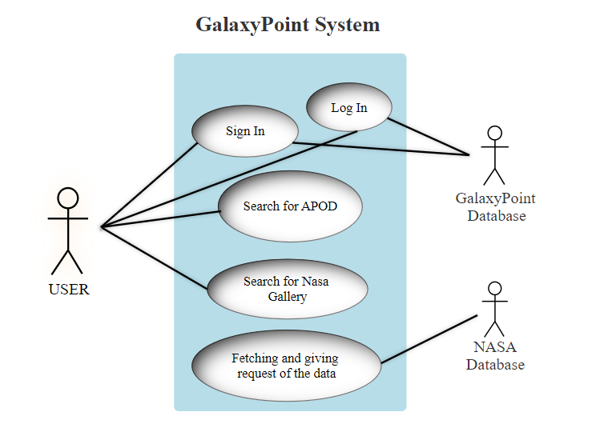

* **How API Work**

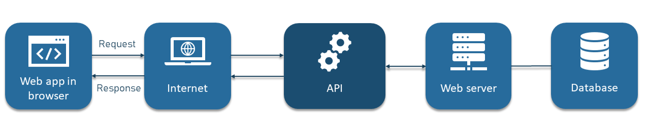

* **ER Diagram**

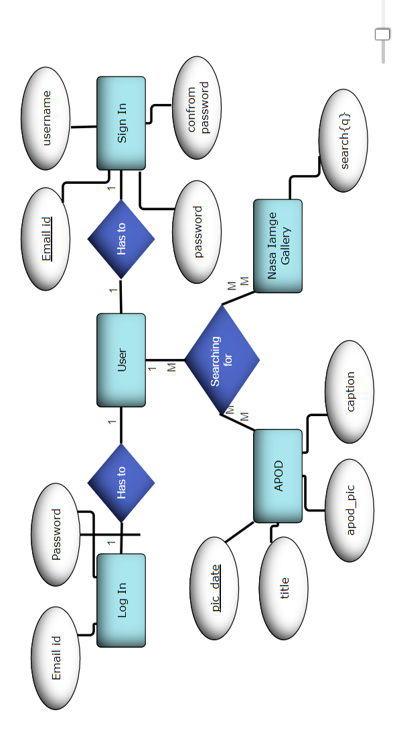

**Hardware Used**

Device Name (PC): HP LAPTOP 15S-GR0XXX

Processor: AMD Ryzen 3 3250U with Radeon Graphics 2.60 GHz

RAM: 8.00 GB

System Type: 64-bit operating system, x64-based processor

Display Type: 39.62cms (15.6) FHD (1920 x 1080)

**Software Used**

1. Text Editor: Visual Studio Code (VS CODE) *Version 1.83*

2. Web Brower: Chrome 117 and Microsoft Edge*Version 118.0.2088.46*

3. Operating System: Windows 11

4. Design Software: Figma

5. Text Editor: Microsoft Word

6. Image Editor: Adobe Photoshop

7. Programming Languages and Frameworks:

* **Front-End**: HTML5, CSS, JAVASCRIPT
* **Back-End**: MYSQL (Database) and PHP

**Functional Requirements**

**1. User Authentication:** Users should be able to log in with their username and password, with the system verifying their credentials.

**2. Search Functionality:** The website should have a search bar that allows users to search for images and Astronomical pictures of the day.

**3. Data Validation:** The website should validate the format of fields such as email address, phone number, zip code, name, and password.

**4. Sections and Grid View:** Sections andgrids are used to guidelines incorporate margins, spaces, and columns, collectively – providing an encompassing, consistent framework for the page's content.

**Non-Functional Requirements**

**1. Scalability:** The system should be able to handle a growing number of users and content without significant performance degradation.

**2. Security:** User data should be encrypted, and the website should be protected against common web security threats like SQL injection

**3. Usability:** The website should be user-friendly, with an intuitive interface that works on various devices and browsers.

**4. Browser Compatibility:** The website should be compatible with major web browsers (e.g., Chrome, Firefox, Safari, Edge) and different versions of each.

**User Interface(FRONT-END):**

* **HOME PAGE**

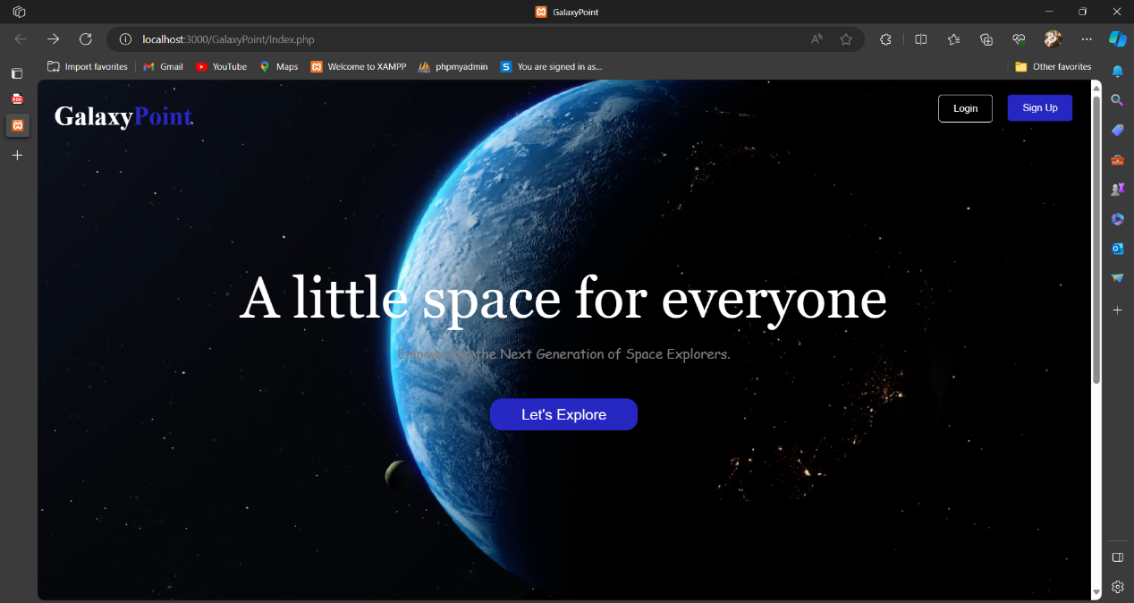

*UI of Home page before log-In and Sign-Up, including Navbar, Footer and Center Part with main button which redirect to Sign-Up page to the user. And Navbar have two buttons log-in and Sign-up which redirect to login and signup page respectively.*

* **SIGN-UP PAGE**

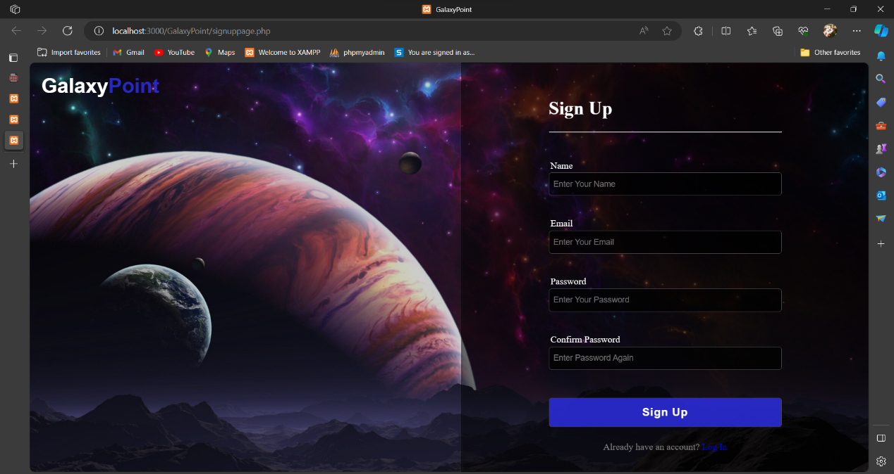

*UI of Sign-Up page after clicking on let’s explore button, here user fill the form to create an account on website. logo on top left corner is a link which redirect to home page.*

**CODE:**

*PHP code of Sign-up from to retrieve data of the user.*

<?php

include('connection.php');

if (isset($_POST['save'])) {

    $name = $_POST['name'];

    $email = $_POST['email'];

    $pass = $_POST['pass'];

    $c_pass = $_POST['c_pass'];

    if ($pass !== $c_pass)

        echo "<script>alert('password and confirm password must be same'); window.location.href = 'signuppage.html'</script>";

    $sql = "INSERT INTO user VALUES(NULL, '$name', '$email', '$pass')";

    if (mysqli_query($conn, $sql)) {

        echo "<script>alert('signup success'); window.location.href = 'loginpage.html'</script>";

    } else {

        echo "<script>alert('Invalid Email/Password'); window.location.href = 'signuppage.html'</script>";

    }

    mysqli_close($conn);

}

?>

* **LOG-IN PAGE**

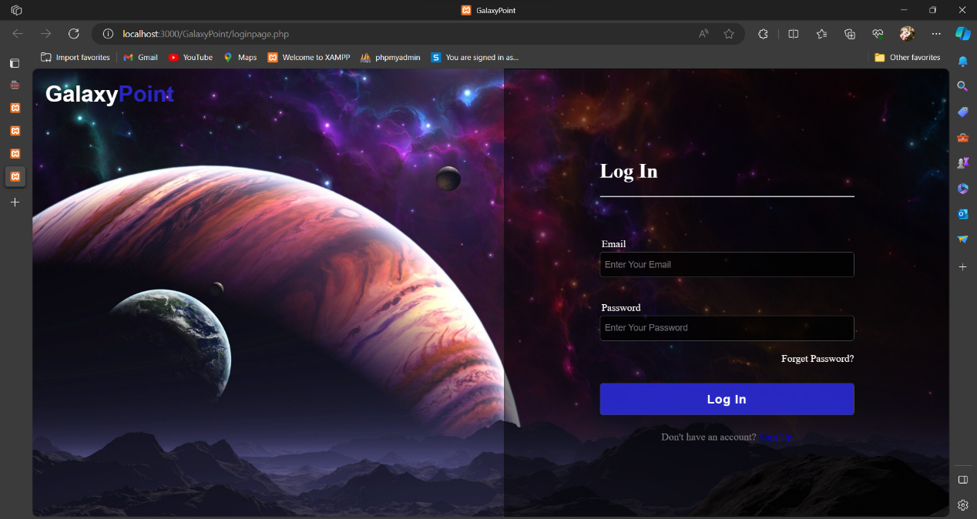

*UI of log-In page, if user already have account then user click on log-in link of sign-up page which go to log-In page and fill the login details (email-id and password) in form for logging.*

**CODE:**

*PHP code of log-in from to enter the register user only.*

<?php

session_start();

?>

<?

include("connection.php");

if (isset($_POST['save'])) {

    $email = $_POST['email'];

    $pass = $_POST['pass'];

    $sql = "select * from user where email='$email' and password='$pass'";

    $res = mysqli_query($conn, $sql);

    if (mysqli_num_rows($res) > 0) {

        $_SESSION['email'] = $email;

        $_SESSION['password'] = $pass;

        echo "<script>alert('login success'); window.location.href = 'index2.php'</script>";

    } else {

        echo "<script>alert('Invalid Email/Password'); window.location.href = 'loginpage.php'</script>";

    }

    mysqli_close($conn);

}

?>

* **MAIN HOME PAGE AFTER LOGGED-IN**

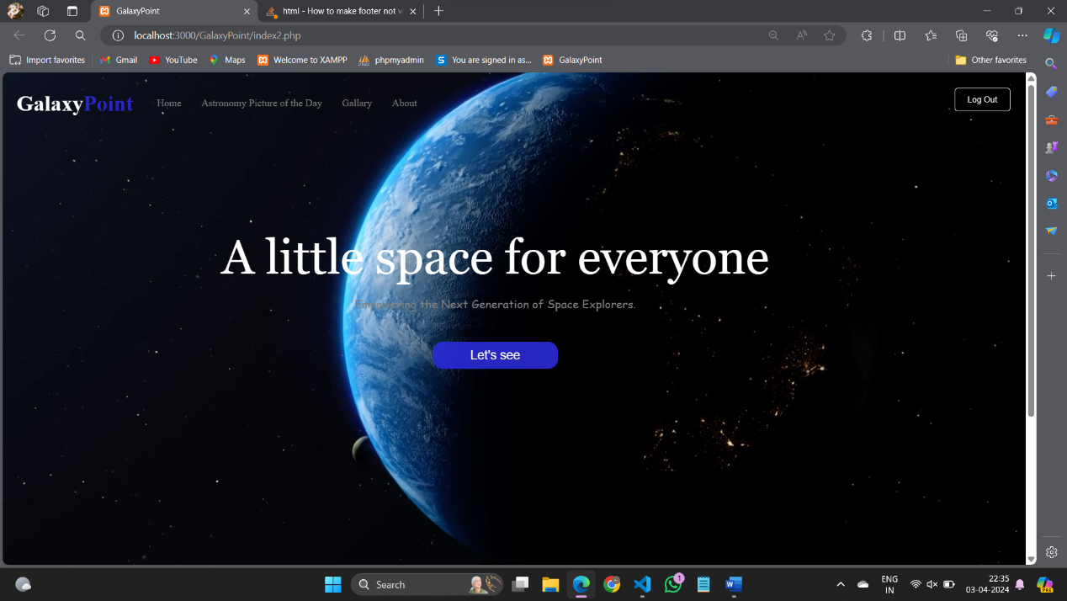

*UI of main home page after Logged-In, including Log-Out button.*

* **NAVBAR(HEADER)**

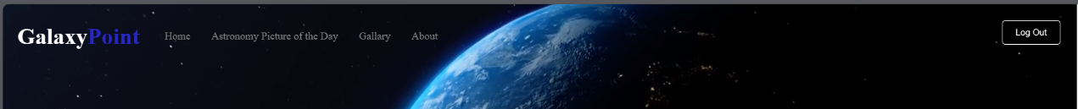

*UI of transparent Navbar including website logo, navbar links Home, Astronomy picture of the Day, About which redirect to Home page, APOD page and About page with hover effect respectively, and Log-Out button for logging-out.*

* **FOOTER**

**

*UI of Footer including many links About, APOD, Log-in, Sign-up, Nasa API, Contact , Trems of services, Privacy policy which redirect to their pages And also with Linkedin and Github profile.*

* **APOD PAGE**

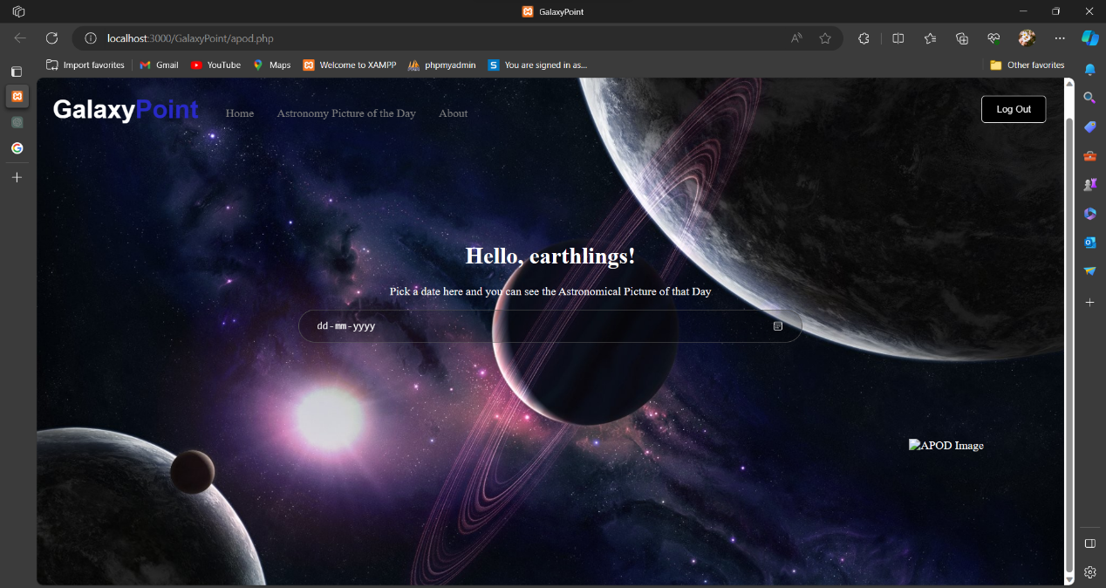

*UI of APOD (Astronomy Picture of the Day) page consist of navbar and center part of the page which includes calendar(Date) where you pick a date from calendar and result shows the astronomy picture of the selected date.*

* **APOD PAGE SEARCH RESULT**

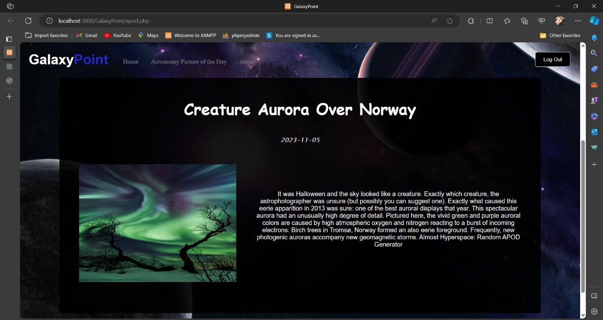

*UI of APOD page after selected date, div box appear with result of search date including content of title of APOD-picture, Pickup date, Image of APOD and information of the image.*

**CODE:**

*Javascript code of fetch Astronomy picture of the Day from Nasa APOD Api which fetch information live from the Nasa Database and show result to our website.*

*Nasa shared to us by their user authentication by special key called an* ***Application programming interface (API)*** *key.*

***Used API Key* : “HnAA7BJ0pESGaQ8l8gIYHLi75sKfg7cgQXXY8bHo”**

 <div class="center-part">

        <h1>Hello, earthlings!</h1>

        <p>Pick a date here and you can see the Astronomical Picture of that Day</p>

        <input  class="search_input" type="date"  onclick="hideshow()" onfocus="(this.type = 'date')"  id="date" onchange="getDate();">

        <div class="output">

            <h3 class="img-title" id="title"></h3>

            <em class="date" id="pic_date"></em>

            <img src="" alt="APOD Image" id="apod_pic" class="img-apod">

            <p class="caption" id="caption"></p>

        </div>

        <script type="text/javascript">

        // Declaration of variables

        var method = "GET";

        const key =

        "HnAA7BJ0pESGaQ8l8gIYHLi75sKfg7cgQXXY8bHo";

        var url =

        "https://api.nasa.gov/planetary/apod?api_key="

                + key + "&date=";

        var mode = true;

        var date;

        // Function definition to get date from

        // input box and supply in sendHttpRequest

        // function

        function getDate() {

            date = document.getElementById("date").value;

            console.log(date);

            sendHttpRequest(method, url + date,

                mode).then((data) => {

                console.log(data);

                update(data);

            });

        }

        // Declaration of update function to

        // display the fetched data on webpage

        function update(data) {

            document.getElementById("pic_date")

                .innerHTML = data.date;

            document.getElementById("title")

                .innerHTML = data.title;

            document.getElementById("apod_pic")

                .src = data.url;

            document.getElementById("caption")

                .innerHTML = data.explanation;

            return data;

        }

        // Send request to nasa portal to data

        // using the XMLHttpRequest

        function sendHttpRequest(method, url, mode) {

            return new Promise((resolve, reject) => {

                var req = new XMLHttpRequest();

                req.onreadystatechange = function () {

                    if (this.readyState == 4) {

                        if (this.status == 200) {

                            var data = JSON

                                .parse(this.response);

                            console.log(data);

                            resolve(data);

                        }

                    }

                }

                req.open(method, url, mode);

                req.send();

            });

        }

        </script>

    </div>

* **GALLERY PAGE**

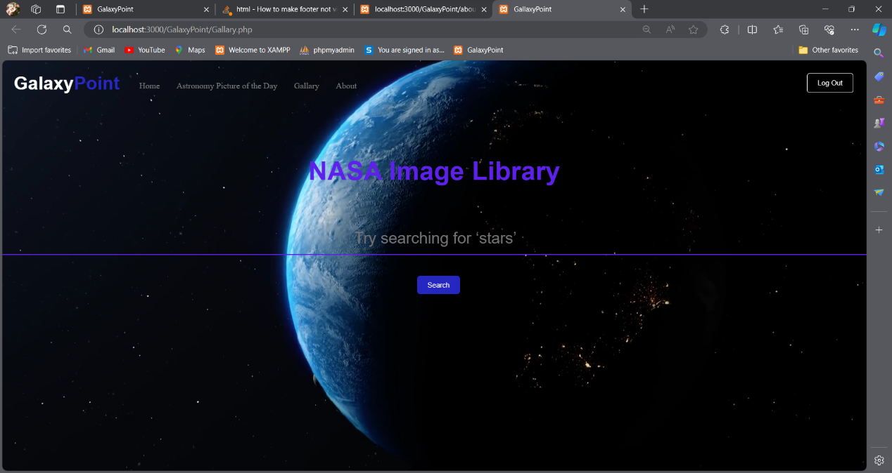

*UI of Gallery page consist of navbar and center part of the page which includes search bar where you search any keyword and result shows the images from the Nasa image Gallery API which consist of Nasa database.*

* **GALLERY PAGE SEARCH RESULT**

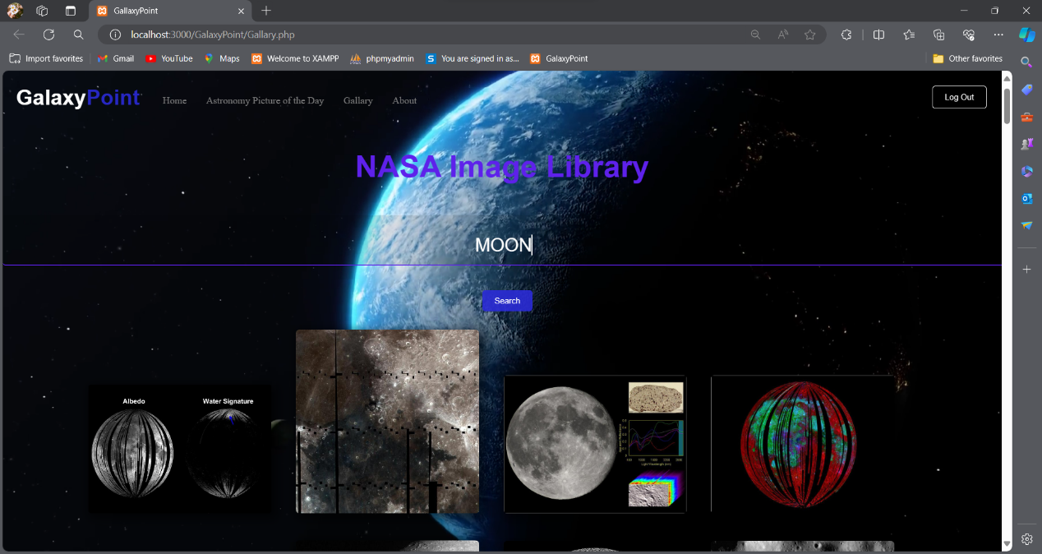

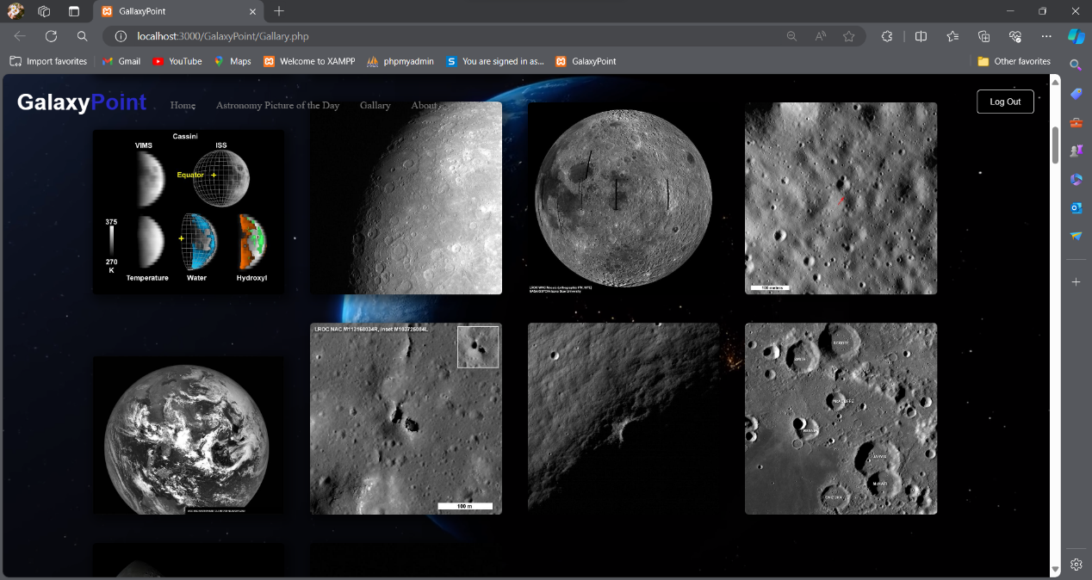

*UI of Gallery page after search, result shows the in a grid view of images from the NASA Database.*

**CODE:**

*Javascript code of fetch images from Nasa Image Library Api which fetch images live from the Nasa Database and show result to our website.*

<script>

    async function searchImages() {

      const searchQuery = document.getElementById('searchInput').value.trim();

      if (searchQuery === '') {

        alert('Please enter a search term');

        return;

      }

      try {

        const response = await fetch(`https://images-api.nasa.gov/search?q=${searchQuery}&media_type=image`);

        const data = await response.json();

        displayImages(data.collection.items);

      } catch (error) {

        console.error('Error fetching data:', error);

      }

    }

    function displayImages(items) {

      const imageResultsContainer = document.getElementById('imageResults');

      imageResultsContainer.innerHTML = '';

      items.forEach(item => {

        const imgUrl = item.links[0].href;

        const title = item.data[0].title;

        const imageElement = document.createElement('img');

        imageElement.src = imgUrl;

        imageElement.alt = title;

        imageElement.style.maxWidth = '300px';

        imageElement.style.cursor = 'pointer';

        imageElement.addEventListener('click', function() {

          openModal(imgUrl, title);

        });

        imageResultsContainer.appendChild(imageElement);

      });

    }

    function openModal(imgUrl, title) {

      document.getElementById('modal').style.display = 'block';

      document.getElementById('fullImage').src = imgUrl;

      document.getElementById('fullImage').alt = title;

      document.getElementById('modal-content').style.display = 'block';

    }

    document.getElementById('close').addEventListener('click', function() {

      closeModal();

    });

    function closeModal() {

      document.getElementById('modal').style.display = 'none';

    }

    var input = document.getElementById("searchInput");

   input.addEventListener("keypress", function(event) {

  if (event.key === "Enter") {

    event.preventDefault();

    document.getElementById("mybtn").click();

  }

});

  </script>

* **ABOUT PAGE**

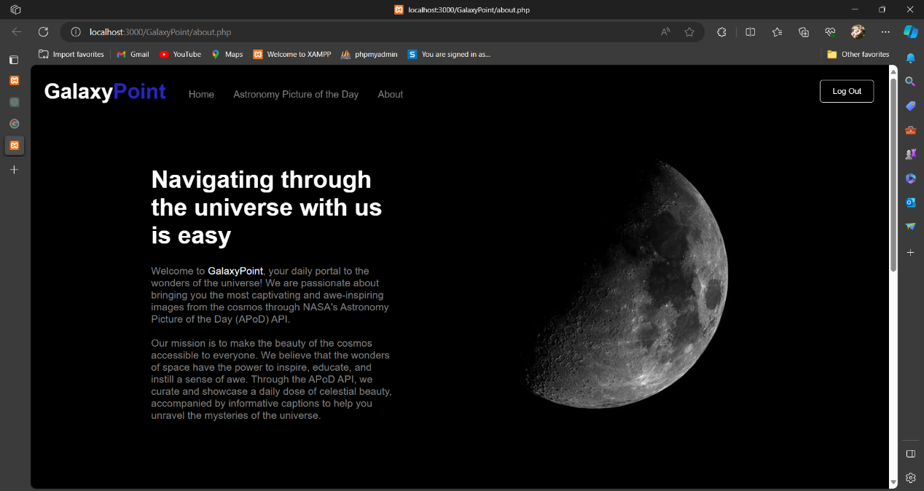

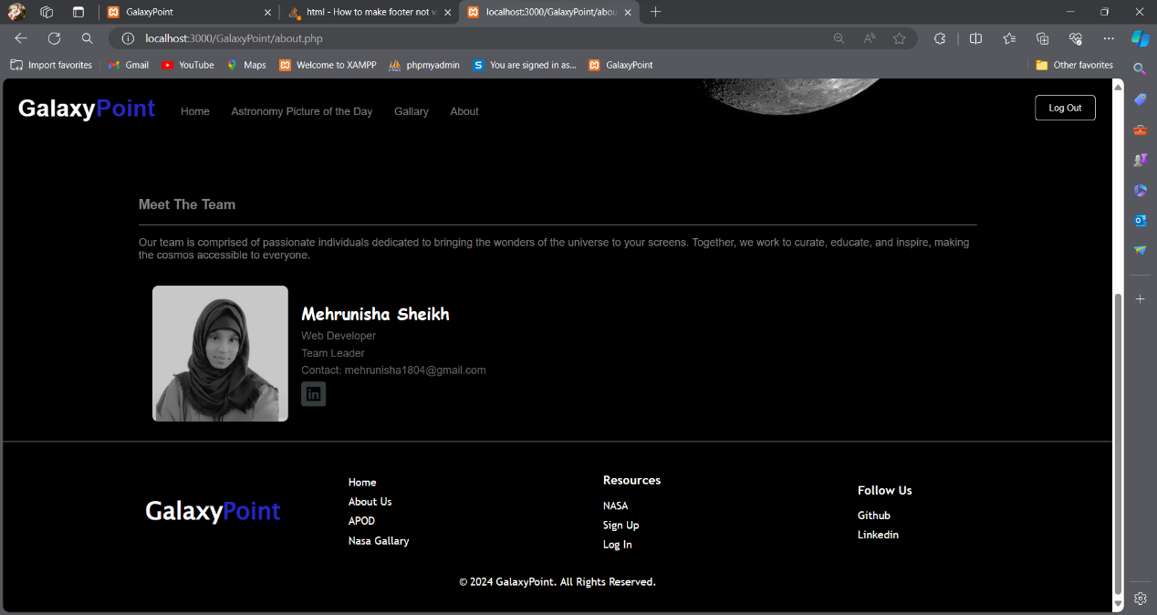

*UI of About page consist of Header, Footer, Mission section content and Meet the team section where information about the GalaxyPoint team.*

**BACK-END (DATABASE)**

*For backend Database connection we use XAMP Server to store data at phpMyAdmin.*

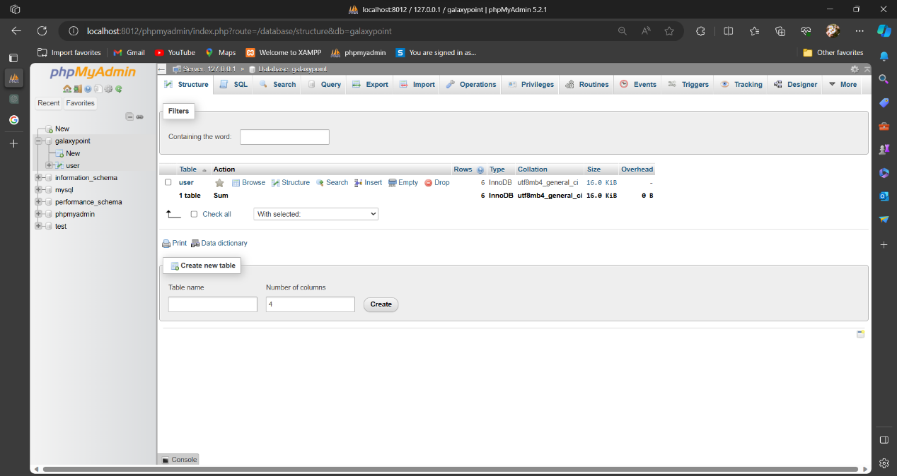

**CODE:**

*Database connection PHP code of user to store in database.*

<?php

session_start();

$servername = "localhost";

$username = "root";

$password = "";

$database = "galaxypoint";

$conn = mysqli_connect($servername, $username, $password, $database);

if (! $conn)

{

    die("Connection failed".mysqli_connect_error());

}

?>

*When user fill Sign-up from details on clicking sign-up button then data store at the XAMP server of phpmyadmin in the GalaxyPoint database at user table. Only register user log-in to the website whose data already stored in website database.*

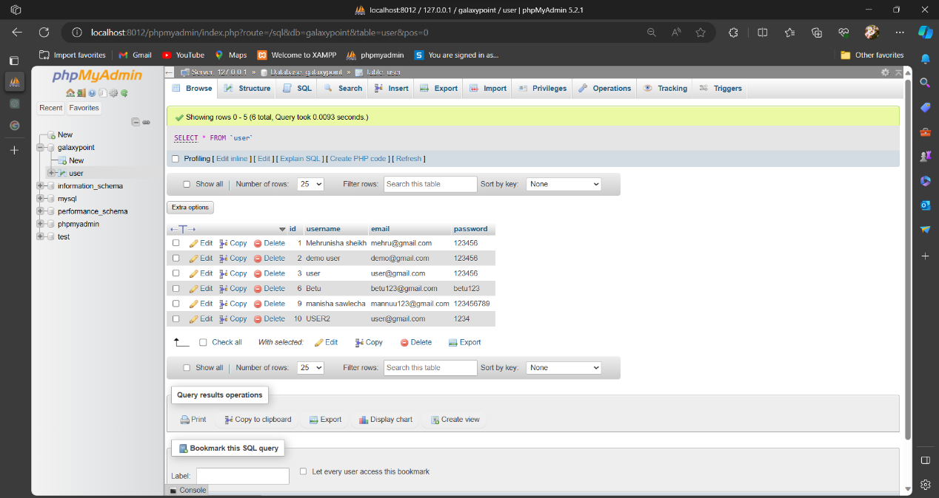

*Details of the register users in GalaxyPoint Database.*

s

**Testing technologies:**

* Functional Testing:
  + Selenium: For automated testing of web applications, including interaction with web elements and verifying expected behaviors.
  + Postman: For API testing, specifically to validate the integration with NASA's API endpoints and response data.
* Performance Testing:
  + Apache JMeter: For load testing to simulate concurrent user traffic and measure the website's performance under various load conditions.
  + Google Lighthouse: For assessing website performance, accessibility, best practices, and SEO metrics.
* Compatibility Testing:
  + BrowserStack: For cross-browser testing, allowing testing across multiple browsers and versions to ensure consistent behavior.
  + Responsive Design Testing Tools: Such as Responsive Design Checker, to verify website responsiveness across different devices and screen sizes.
* Security Testing:
  + OWASP ZAP (Zed Attack Proxy): For detecting and mitigating security vulnerabilities, including injection flaws, XSS attacks, and security misconfigurations.
  + SSL Labs: For assessing SSL/TLS implementation and identifying potential vulnerabilities related to secure communication.
* Usability Testing:
  + UserTesting: For conducting remote usability testing with real users, providing valuable insights into user interactions and feedback.
  + Google Analytics: For analyzing user behavior and engagement metrics to identify areas for improvement in the website's usability.

**What contribution would the project make?**

**Science Education:** Your website can serve as an educational platform, offering information and insights into the world of astronomy and space science. It can explain the significance of astronomical events and phenomena, helping to demystify complex topics for a broader audience.

**Inspiration:** Sharing stunning astronomical images and the latest discoveries can inspire people to take an interest in space science. These visuals can ignite curiosity and a sense of wonder, motivating individuals to explore the cosmos further.

**Access to Space News:** Providing the latest space-related news and updates allows your website to keep the public informed about current events and discoveries in the field of space exploration and astronomy.

**Curation:** By curating content related to astronomical pictures, space galleries, and space news, your website simplifies the process of finding relevant and high-quality information for those interested in space science.

**Links to Official Sources:** While your website may not be an official NASA site, it can link to authoritative sources like NASA and other space agencies, ensuring that users can access in-depth information when needed.

Our website, as a ***"lite"*** version of a space-related platform, can play an important role in sharing knowledge, fostering curiosity, and building a community of space enthusiasts and learners. It contributes to the popularization of space science and helps make astronomical information more accessible to the general public.

**Limitation:**

**Technical Limitations:**

* Internet Speed: Users with slow internet connections may experience difficulties in loading content-heavy websites.
* Device Compatibility: Ensuring a consistent user experience across different devices, such as smartphones, tablets, and desktops, can be challenging.

**Accessibility:** Ensuring a website is accessible to individuals with disabilities can be challenging, and not all websites are built with accessibility in mind. A website that lacks proper accessibility features may exclude potential users.

**Limited Offline Access:** Websites typically require an internet connection to function properly. They can't provide the same level of functionality when users are offline.

**References:**

* GitHub: https://github.com/features/code-search
* YouTube: https://www.youtube.com/
* Nasa.gov: https://www.nasa.gov/
* Api.nasa.gov: https://api.nasa.gov/
* GeeksforGeeks: https://www.geeksforgeeks.org/
* JavaTpoint: https://www.javatpoint.com/
* Stack Overflow: https://stackoverflow.com/
* W3Schools: https://www.w3schools.com/